Home Assignments – week 3 Day 1 21 FEB
1) Use Bugmagnet and Fake filler extension for form filling
2) Use grammarly extension to correct the mistakes in your content
3) Vibe Coding Generate Playwright Typescript 0r (any tool with language binding in which you are working)

- Use Bugmagnet and Fake filler extension for form filling.
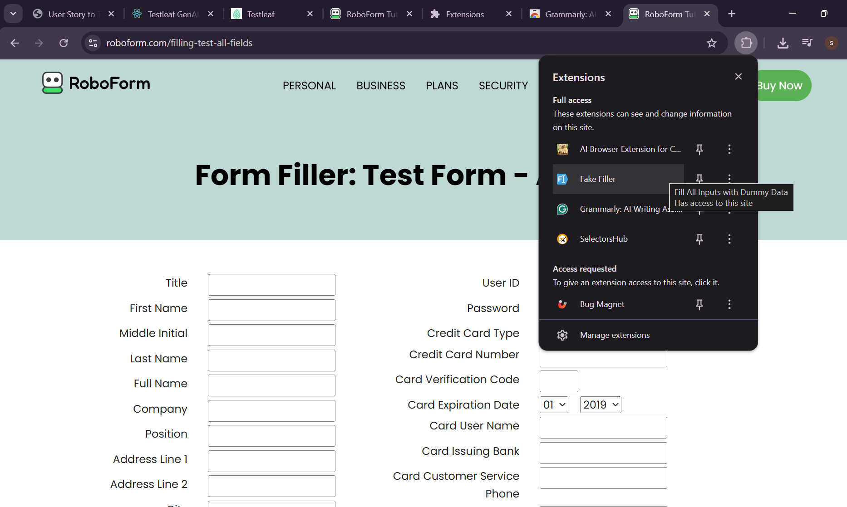

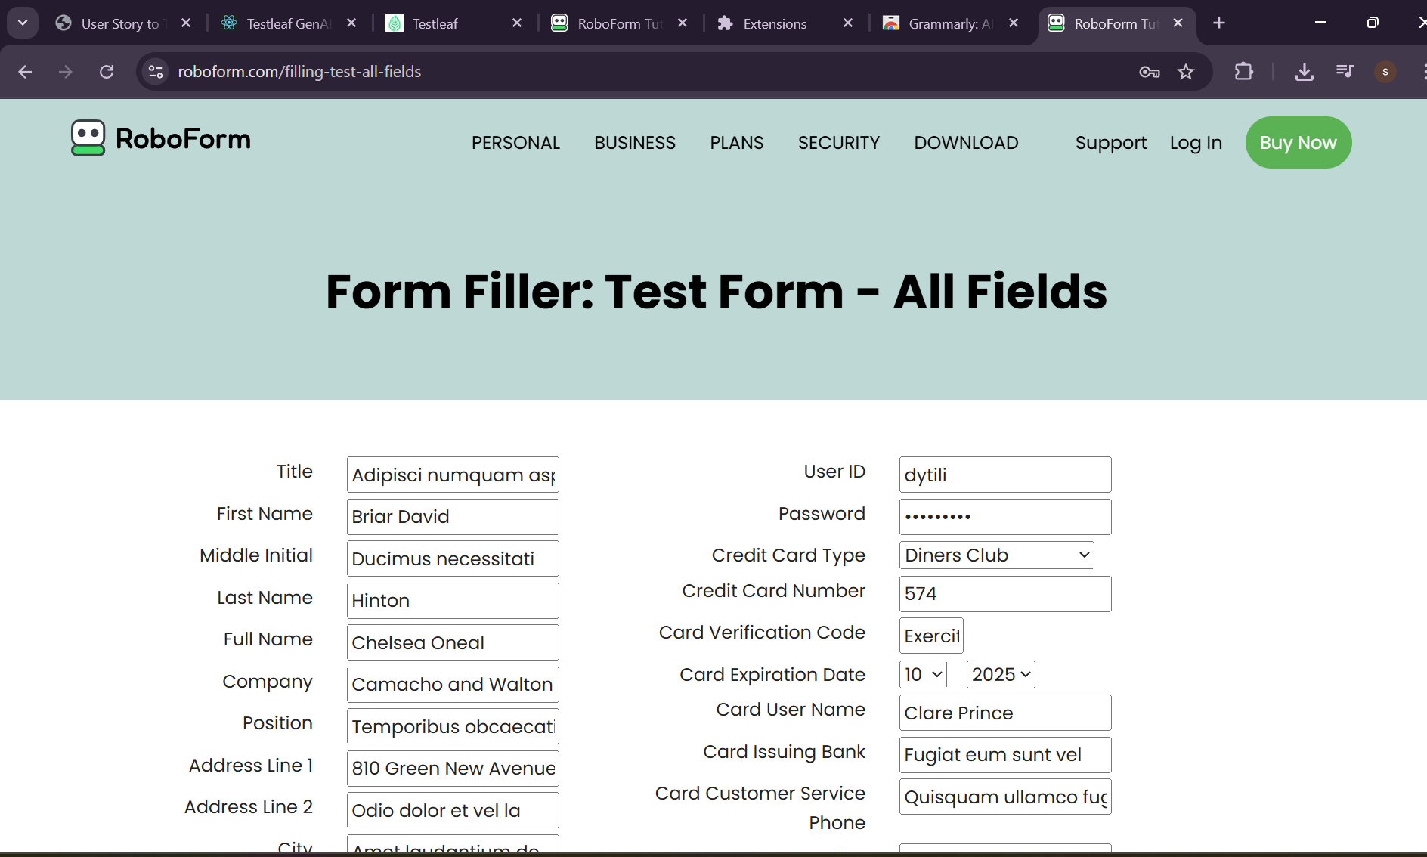
- Use grammarly extension to correct the mistakes in your content.
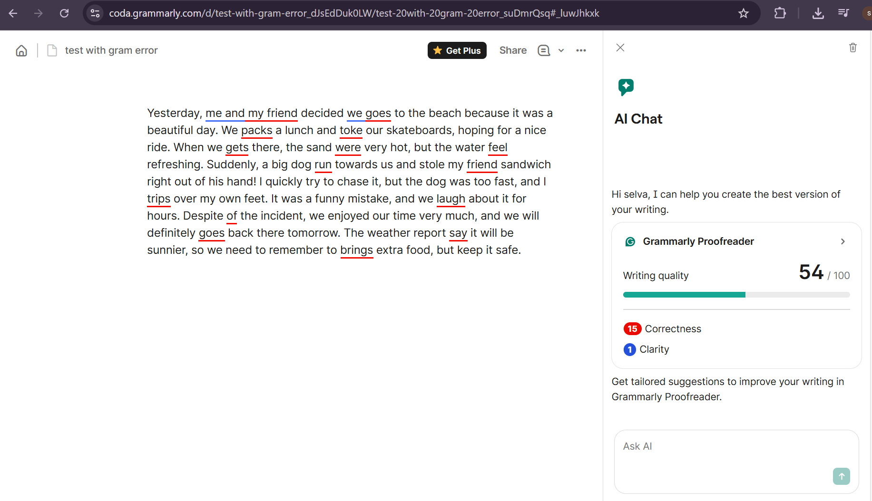
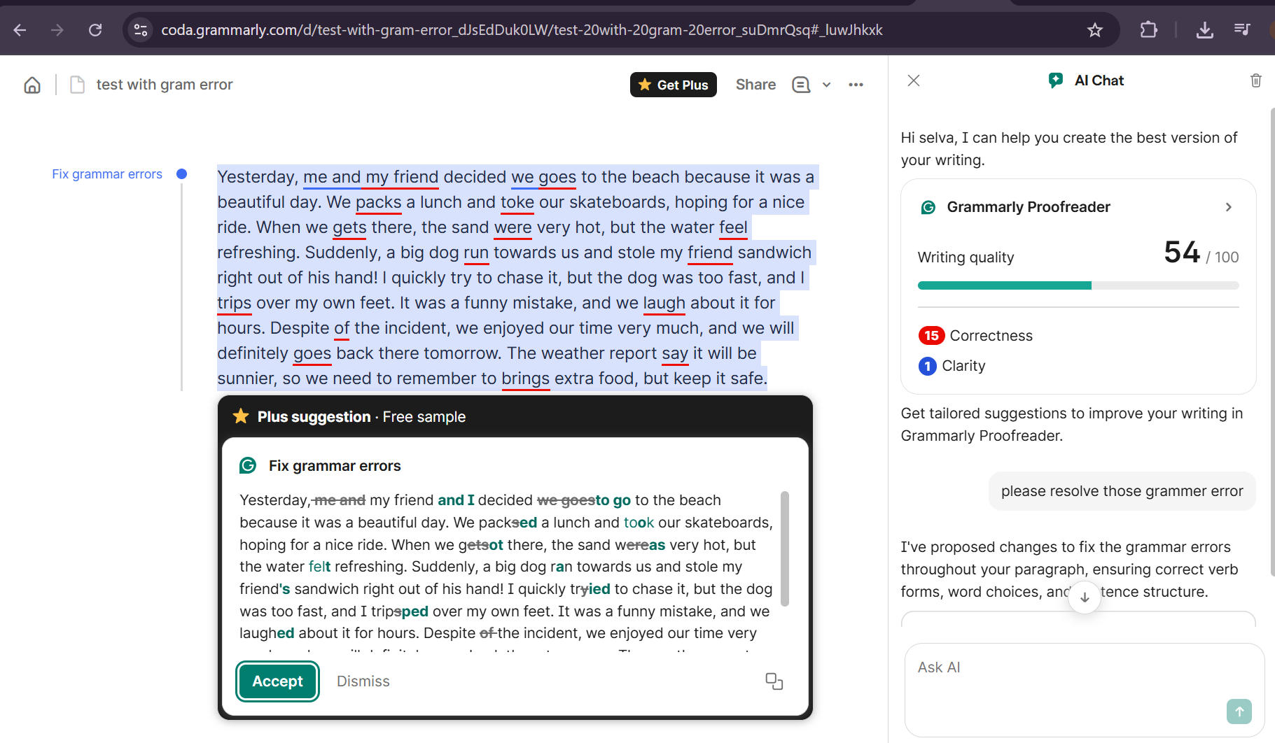
3) Vibe Coding Generate Playwright Typescript 0r (any tool with language binding in which you are working)

